|  |  |  |
| --- | --- | --- |
|  |  | Moodle 3.1 upgrade @ GOTAFE  Test schedule + issues register |

Greg Bird 29.09.16

RESULTS OF Test schedule 2

General 2

Course content 2

Further information: 5

Issues register 6

New assignment grading UX displays a blank screen, rather than the student submitted work (Word, PPT etc.) 6

Cannot add OUWiki tool – Throws errors 7

# RESULTS OF Test schedule

As suggested by Bernadette:

## General

1. general look of your site – eg any text that does not wrap correctly, differently coloured text, images that do not display the correct size, etc  
   ../../../../Downloads/firefox-extension-html-validator-icons-clip-art/Firefox_Extension_Htmlvalidator_Icons_clip_art_small.png ***-***  *Some display issues exist, but these can be easily rectified through custom CSS.*Example: Grade button in new assignment grading UX  
   
2. Language pack changes – if you have existing changes/edits in your language pack, then check that they display as expected  
   ../../../../Downloads/firefox-extension-html-validator-icons-clip-art/Firefox_Extension_Htmlvalidator_Icons_clip_art_small.png ***UNTESTED*** *– GOTAFE does not use custom language packs*
3. Any links to http content that you may find will need to be updated to https

../../../../Downloads/firefox-extension-html-validator-icons-clip-art/Firefox_Extension_Htmlvalidator_Icons_clip_art_small.png ***NOT SURE HOW TO TEST*** *– Moodle 3.1 still accepts http links to external websites. is this where you have used internal links, between Moodle tools (eg. link to an assignment from within a book?)*

1. If you notice any issues, please test in another theme or course format to see if this is the issue – and let us know your findings  
   ../../../../Downloads/firefox-extension-html-validator-icons-clip-art/Firefox_Extension_Htmlvalidator_Icons_clip_art_small.png - Switching to Clean theme resolves the display issues detected to-date. This isolates the GOTAFE themes are the root cause. Greg to resolve.
2. Test backing up and restoring a course with various different content types  
   ../../../../Downloads/firefox-extension-html-validator-icons-clip-art/Firefox_Extension_Htmlvalidator_Icons_clip_art_small.png../../../../Downloads/firefox-extension-html-validator-icons-clip-art/Firefox_Extension_Htmlvalidator_Icons_clip_art_small.png (***PARTIALLY TESTED)*** *– Backup and restore appears to work well. GoTAFE only use one format (oneTopic), so have not tested other formats*
3. Test importing content from another course.

../../../../Downloads/firefox-extension-html-validator-icons-clip-art/Firefox_Extension_Htmlvalidator_Icons_clip_art_small.png../../../../Downloads/firefox-extension-html-validator-icons-clip-art/Firefox_Extension_Htmlvalidator_Icons_clip_art_small.png (***PARTIALLY TESTED)*** *– Have tested importing of limited content types (Books, quizzes, labels). No issues found to date, but needs to be more thoroughly tested*

## Course content

1. **Course formats**
   1. if your site uses different course formats, test on each eg onetopic, tile, topics, weekly, etc

../../../../Downloads/firefox-extension-html-validator-icons-clip-art/Firefox_Extension_Htmlvalidator_Icons_clip_art_small.png *There are some display issue with the Tiles format, but I believe that this is due to the fact that the base theme that GOTAFE uses is not compatible with this format. Whilst we would love to use this format, we cannot do so, whilst there are issues with it (as previously reported and discussed at TAG)*

* 1. test deleting topics in a course

../../../../Downloads/firefox-extension-html-validator-icons-clip-art/Firefox_Extension_Htmlvalidator_Icons_clip_art_small.png *Deleting a section correctly deletes the section plus contained content and activities*

* 1. test hide/unhide topics  
     ../../../../Downloads/firefox-extension-html-validator-icons-clip-art/Firefox_Extension_Htmlvalidator_Icons_clip_art_small.png *Hidden content properly obeys the settings, as configured under   
     Edit sections > Hidden sections (ie completely hidden or collapsed)*

1. **SCORM**packages that you may have:
   1. grades go back to the grade book  
      ../../../../Downloads/firefox-extension-html-validator-icons-clip-art/Firefox_Extension_Htmlvalidator_Icons_clip_art_small.png *SCORM grading appears to work. Students receive immediate feedback and grades appear in the gradebook. SCORM reporting provides detail*
   2. when you leave a SCORM unfinished, you can return to the same spot later  
      ../../../../Downloads/firefox-extension-html-validator-icons-clip-art/Firefox_Extension_Htmlvalidator_Icons_clip_art_small.png ***MIXED RESULTS – REQUIRES INDEPENDENT TESTING*** *– Whilst the tracking appears to be working (as evidenced by ticks in the navigation column) the user is NOT returned to where they left off (ie resume appears not be functioning)*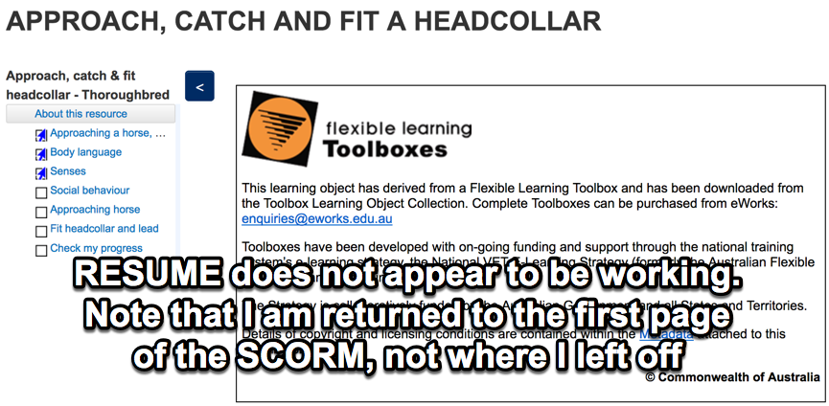
   3. the SCORM displays as it should  
      ../../../../Downloads/firefox-extension-html-validator-icons-clip-art/Firefox_Extension_Htmlvalidator_Icons_clip_art_small.png../../../../Downloads/firefox-extension-html-validator-icons-clip-art/Firefox_Extension_Htmlvalidator_Icons_clip_art_small.png ***PARTIALLY TESTED***. *I have randomly sampled a range of SCORM’s. Whilst they appear to work fine, they may not be representative of the behavior of all SCORM’s*
2. **Assignments**(nice new features):
   1. assignments grade as expected, and grade goes to grade book  
      ../../../../Downloads/firefox-extension-html-validator-icons-clip-art/Firefox_Extension_Htmlvalidator_Icons_clip_art_small.png *Grades and comments are stored as expected. Results go back to the grade-centre*
   2. quick grading works as expected  
      ../../../../Downloads/firefox-extension-html-validator-icons-clip-art/Firefox_Extension_Htmlvalidator_Icons_clip_art_small.png***FAILED*** *– A blank page is shown where the Student submission (Word, PPT etc), should appear.* ***See issues register lower***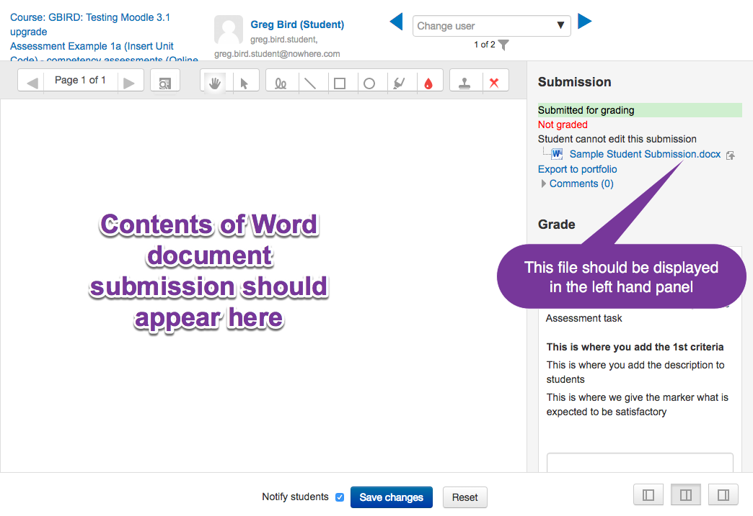
   3. if you are using grading workflows, check they work as expected

../../../../Downloads/firefox-extension-html-validator-icons-clip-art/Firefox_Extension_Htmlvalidator_Icons_clip_art_small.png ***UNTESTED*** *– GOTAFE does not use grading workflows*

* 1. pages load as expected (note: in the grading page, the top left of the page has the course name, assignment name and due date. If the course name is very long, then some of this detail gets over-written by the grading area. This has been reported.)

../../../../Downloads/firefox-extension-html-validator-icons-clip-art/Firefox_Extension_Htmlvalidator_Icons_clip_art_small.png***FAILED*** *– See above (and the issues register, lower)*

1. **Quizzes**:
   1. appear as expected  
      ../../../../Downloads/firefox-extension-html-validator-icons-clip-art/Firefox_Extension_Htmlvalidator_Icons_clip_art_small.png *Quiz appearance and behavior is as expected*
   2. test drag and drop questions (these are now core Moodle) ie create new questions and test existing drag-n-drop questions  
      ../../../../Downloads/firefox-extension-html-validator-icons-clip-art/Firefox_Extension_Htmlvalidator_Icons_clip_art_small.png *Created questions to each available question type, including drag and drop. Behavior is as expected*
   3. ‘grade to pass’ works if you use it (ie save this setting, then edit the quiz again to check the setting ‘sticks’)

../../../../Downloads/firefox-extension-html-validator-icons-clip-art/Firefox_Extension_Htmlvalidator_Icons_clip_art_small.png *Grades to pass is functioning. Results go to gradecentre. Can be used as the baisis of activity completion.*

1. **Forums**

Anonymous posting – should you want to use this option  
../../../../Downloads/firefox-extension-html-validator-icons-clip-art/Firefox_Extension_Htmlvalidator_Icons_clip_art_small.png***UNAVAILABLE*** *– Anonymous posting requires a separate plugin, which has not been deployed https://moodle.org/plugins/local\_anonymousposting*

* 1. Check you can pin a forum discussion to keep it at the top for easy access  
     ../../../../Downloads/firefox-extension-html-validator-icons-clip-art/Firefox_Extension_Htmlvalidator_Icons_clip_art_small.png../../../../Downloads/firefox-extension-html-validator-icons-clip-art/Firefox_Extension_Htmlvalidator_Icons_clip_art_small.png ***LIMITED TESTING -***  *I have successfully pinned a post, but it requires a fully populated forum with many top-level posts before this shows any benefit*

1. **Certificates**
   1. if you use customised certificate templates, check they are available  
      ../../../../Downloads/firefox-extension-html-validator-icons-clip-art/Firefox_Extension_Htmlvalidator_Icons_clip_art_small.png ***UNTESTED*** *– GOTAFE does not use* customised certificate templates
2. **OU blog and OU wiki**have not been updated for Moodle 3.1. If you find any issues, please create a ticket.  
   **OU blog -** ../../../../Downloads/firefox-extension-html-validator-icons-clip-art/Firefox_Extension_Htmlvalidator_Icons_clip_art_small.png../../../../Downloads/firefox-extension-html-validator-icons-clip-art/Firefox_Extension_Htmlvalidator_Icons_clip_art_small.png ***LIMITED TESTING -***  *I have added these tools and successfully added content to each, but it needs the input of other users to properly test these.****OU wiki***../../../../Downloads/firefox-extension-html-validator-icons-clip-art/Firefox_Extension_Htmlvalidator_Icons_clip_art_small.png ***- Broken, Throws errors.*** *Unable to add this activity. It throws a 500 error:*

*The gotafetest31.trainingvc.com.au page isn’t working*

***gotafetest31.trainingvc.com.au****is currently unable to handle this request.*

1. **Recycle bin**– try it! The link to the bin will not display if it is empty. You can change the amount of time a course or activity will remain available at Administration> Site administration> Plugins> Admin tools> Recycle bin. See <https://docs.moodle.org/31/en/Recycle_bin>  
   ../../../../Downloads/firefox-extension-html-validator-icons-clip-art/Firefox_Extension_Htmlvalidator_Icons_clip_art_small.png../../../../Downloads/firefox-extension-html-validator-icons-clip-art/Firefox_Extension_Htmlvalidator_Icons_clip_art_small.png *I was able to successfully restore deleted items (a great feature). Interesteringly, if the activity was deleted as a result of deleting an entire section, the activity is restored into the general section.*

## Further information:

1. Preventing duplicate email addresses is possible, but not recommended<https://docs.moodle.org/31/en/Upload_users#Prevent_email_address_duplicates>  
   ../../../../Downloads/firefox-extension-html-validator-icons-clip-art/Firefox_Extension_Htmlvalidator_Icons_clip_art_small.png ***UNTESTED*** *We would never allow for duplicate email addresses. By the way, the wording of this is the wrong way around. It should read ‘****Allowing*** *duplicate email ………’*

# Issues register

## New assignment grading UX displays a blank screen, rather than the student submitted work

**Problem:** The new grading UX is intended to display the student submitted work, side by side with the grading. If the student submits a PDF file this works, but it fails for other file types Word, Powerpoint etc.)

Moodle is meant to convert these files into PDF files on the fly, and show this converted file in the left hand panel. Instead, it is simply displaying a blank screen.

**Steps to replicate:**

1. Create a new assignment, with file submission turned on.
2. Log in as a student and submit a Word document file
3. Log in as a teacher and attempt to mark this assignment
4. Note the blank panel on the left of the screen. A converted version of this file shoul appear here

**Possible resolution:**

See here: <https://docs.moodle.org/31/en/Assignment_FAQ#I_get_a_blank_screen_when_trying_to_annotate_online_text_or_uploaded_Word.2FLibreOffice_submissions>

*“The most likely reason for this is that your Moodle site does not have unoconv installed, a program which converts submissions to PDF so the teacher can annotate them.”*

## Cannot add OUWiki tool – Throws errors

**Problem:** When you attempt to add the OUWiki tool, you receive the following error:

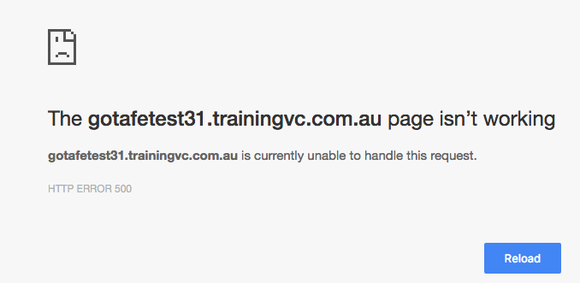

**Steps to replicate:**

1. Attempt to add the OUWiki tool
2. Note the error

**Possible resolution:**

Reinstall the OUWiki plugin?